In paper:
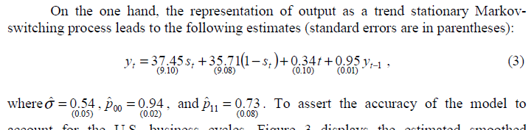

Output of the program :

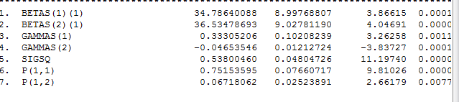

Can you say which one on output (aproximately) refer which one on paper…
For example Is Betas(1,1) Gamas(1) and P(1.1) is 37,45 ; 0.34 and 0.94 , respectively or Not?

- I use also msur-simulate prog. But not able to get these findings,
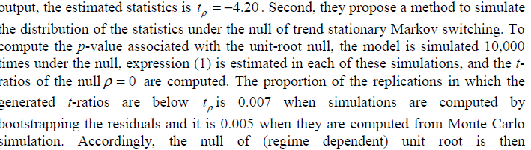
The program just gves emprical results 0.04. What does that number refer?

- How can I find this response graph, is there a code?


