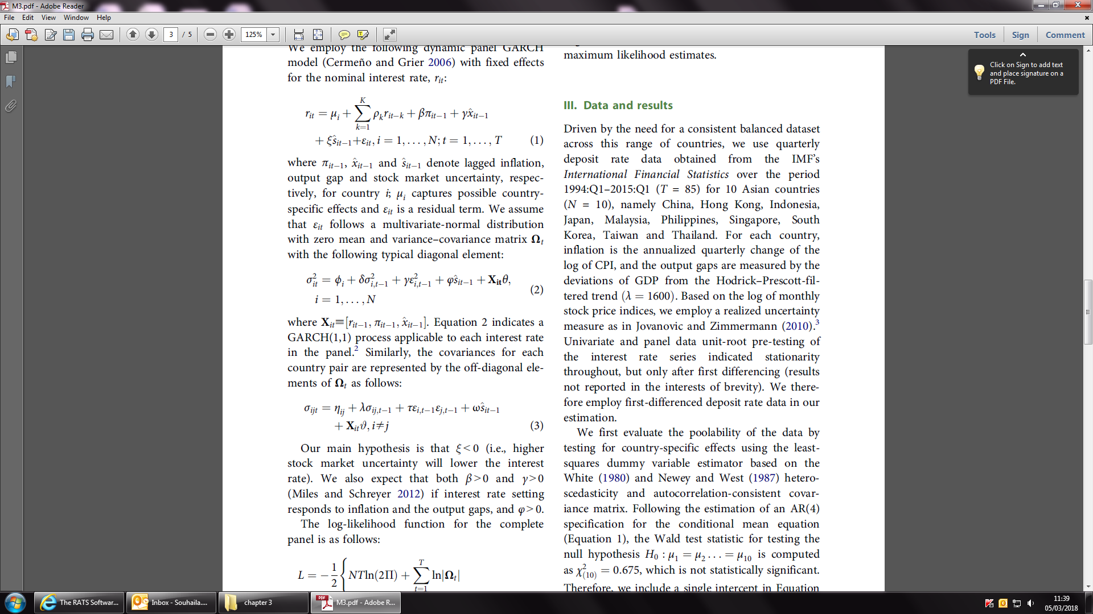

My equations are very similar to the equations in this paper but different dependant and independent variables.

